Warranty/Product Authorization Digitization System



Panasonic Life Solutions Pvt Ltd

Software Requirement Specification (SRS)

The document details the summary of solution architecture and approach for the development of Warranty/Product Authorization Digitization System for Panasonic Life Solutions Pvt Ltd. The document is based on the inputs, system study, discussions and meeting held between BCI & Panasonic Life Solutions Pvt. Ltd. Teams.

**Prepared By: Omkar Gaonkar**

**Submission Date: 29-11-2023**

**Version: 1.2**

BAR CODE INDIA, 691 Udyog Vihar Phase V, Gurugram, Haryana-122016, PH: 0124 4337555

|  |  |  |  |  |
| --- | --- | --- | --- | --- |
| REVISION NO. | DATE | PREPARED BY | REVIEWED BY | COMMENT |
| 1.0 | 23-11-2023 | Omkar Gaonkar | Prateeksha, Chandrakant | SRS Document for Warranty/Product Authorization Digitization System |
| 1.1 | 27-11-2023 | Prateeksha | Chandrakant Shindkar | Modifications as per client’s requirement |
| 1.2 | 29-11-2023 | Omkar | Chandrakant Shindkar | Modifications after Client meeting in QR code Printing and Product Authentication screen |

REVISION HISTORY

**Abbreviations:**

|  |  |
| --- | --- |
| **Name** | **Abbreviation** |
| WIP | Work in Progress |
| API | Application Programming Interface |
| QR Code | Quick Response Code |

**Client:** Panasonic Life Solutions Pvt Ltd.

**Vendor:** Bar Code India

Notice:

This document contains information, which is the proprietary property of Bar Code India. This document is received in confidence and its contents cannot be disclosed or copied without the prior written consent of Bar Code India.

Nothing in this document constitutes a guaranty, warranty, or license, express or implied. Bar Code India disclaims all liability for all such guaranties, warranties, and licenses, including but not limited to: Fitness for a particular purpose; merchantability; not infringement of intellectual property or other rights of any third party or of Bar Code India; indemnity; and all others. The reader is advised that third parties can have intellectual property rights that can be relevant to this document and the technologies discussed herein and are advised to seek the advice of competent legal counsel, without obligation of Bar Code India.

Bar Code India retains the right to make changes to this document at any time, without notice. Bar Code India makes no warranty for the use of this document and assumes no responsibility for any errors that can appear in the document nor does it make a commitment to update the information contained herein.

COPYRIGHT

Copyright © ***BCI*** 2023. All rights reserved.

TRADEMARKS

*Other product and corporate names may be trademarks of other companies and are used only for explanation and to the owners' benefit, without intent to infringe.

Table of Contents

1 Specification Organization 1

2 Introduction 2

2.1 Intended Audience and Reading Suggestions 2

2.2 Project Scope 3

3 Software/Hardware Requirements 4

3.1 Central Server Configuration/Database Servers 4

3.2 Desktop Computers Configuration 4

3.3 Barcode Hardware 4

4 Solution Architecture 5

5 User Interface Specification Conventions 7

6 System Log 8

6.1 Error Logs 8

6.2 Audit Logs 8

7 Application Modules 9

7.1 Application Login- Web Application 9

7.2 User Login 10

7.3 Masters 11

7.3.1 Model Master 11

7.3.2 Configuration Master 11

7.3.3 User Manual Linkage Master 13

7.4 Product Authentication Digitization System 15

7.4.1 QR Code Printing 15

7.4.2 Product Authentication 17

7.4.3 View Customer Details 22

8 Deviation Report 24

9 SRS Scope Change Process 25

9.1 Before Sign Off 25

9.2 After Sign Off 25

9.3 SRS Acceptance 25

# Specification Organization

The objective of the application is to create Warranty/Product Authorization Digitization System that will help in digitizing the Products Authentication and Warranty also provide complete Customer Visibility to Panasonic Life Solutions.

The document lays down the specifications of the application, its architecture and infrastructure requirements.

**Section 1: Introduction**

This section provides hardware requirements and documentation conventions.

**Section 2: User Interface**

This section depicts screen design and logic flow, and is categorized into two groups:

* Application Master Module
* Common Routine

**Section 3: System Architecture**

This section provides information of system architecture.

# Introduction

## Intended Audience and Reading Suggestions

The scope of the software would require the development of the web application, and services for transferring data from application to Server. The document lays down the specifications of the application, its architecture and infrastructure requirements.

The entire solution consists of followings:

1. Web Application (Panasonic Life Solutions to maintain the master data and Reporting)(Angular)
2. Web Application (Consumer Portal)(Angular)
3. REST/API (.Net Core)
4. QR Code Printing (To be used in Manufacturing Plant)
5. Barcode Hardware (Printers & Scanners)
6. MSSQL (Database) (To be confirmed by Customer)

## Project Scope

The scope of the software would require the development of the web application, and services for transferring data from application to Server. The document lays down the specifications of the application, its architecture and infrastructure requirements.

The web application will be developed through which QR Code will be printed for each Product Unit and having Model Code and Serial Number. On scanning QR Code, Customers can authenticate the Product and download the user manual for their product from a web page after filling up the request form.

Using the application, Panasonic Life Solutions can also able to view and export Customers details who has authenticated the Product and also downloaded the User Manual and has visibility of their customers.

The entire solution consists of followings:

1. QR Code Generation (User printing QR Code label)
2. Consumer Web Page (Costumer authenticated the Product and downloaded User Manual )
3. Admin Portal (Panasonic Life Solutions user check Manual Linkage and Reports)

# Software/Hardware Requirements

## Central Server Configuration/Database Servers

The solution would require the high performance server with minimum of following:

**Configuration for Virtual Machine:**

* RAM : 32GB
* CPUS : 4 Cores
* Disk Type : Standard SSD
* Disk Type SSD LRS : 512 GB

**Configuration for Database:**

* Database Version: SQL server 2019 Standard.
* Database type: DTU type (Database Transaction Units)
* Storage: 100 DTUs 500 GB Storage

## Desktop Computers Configuration

The desktop application would require the computer with following specifications:

* i5/i7 Processor with Windows 10 operating System
* 8 GB RAM
* 100GB HDD
* Dot net Framework 4.8

## Barcode Hardware

* Thermal Ink Jet Printer(TIJ) Printer
* Fixed Mount Scanner

# Solution Architecture

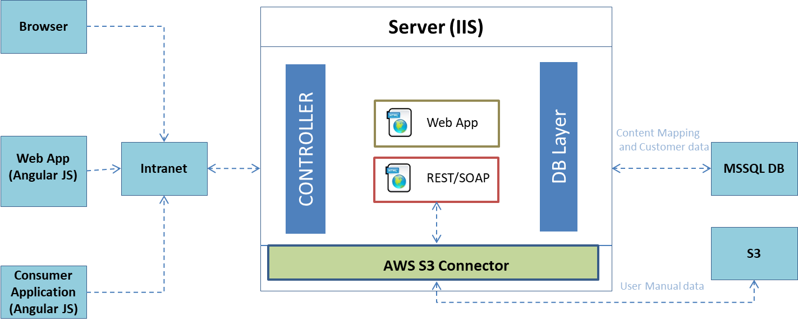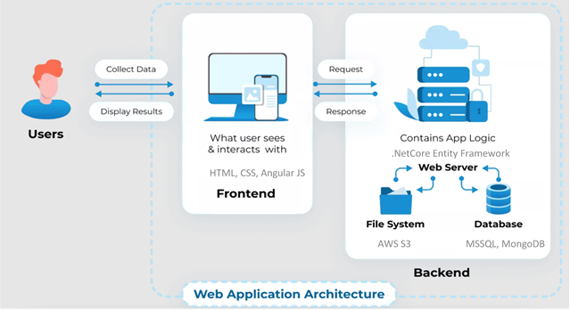

# User Interface Specification Conventions

This section specifies the user interface portion of the application.

**Section Organization**

The User Interface Specification presents screen displays or “**Dialogs**”.

**Documentation Conventions**

This section incorporates illustrations of the application user interface. Each screen display “Dialog” consists of the screen display image, a process name, a paragraph documenting the processing required for the dialog, a paragraph listing the navigation options, and a table listing for each variable field on the dialog, its database source or destination, format, and any instructions required to process the field.

The following section contains a sample dialog with each area identified.

# System Log

System shall maintain internal logs for application.

## Error Logs

These logs will contain any errors encountered during runtime for faster resolution of any problem post deployment.

## Audit Logs

These logs will monitor the activities of user who accessed the application, made changes to File/ Document and the time stamp of these activities.

# Application Modules

## Application Login- Web Application

This login module will provide access to the application modules. Here the admin/user needs to enter the login detail to enter in the application and to perform the desired actions.



**Process:** User needs to enter the User Name/ID and Password in display fields and press the Login button.   
*Application will validate the credentials with the Panasonic Life Solution Database.*

*User will be able to view only those screens/ modules.*

**Validation**

* User Name/ ID will be unique for all users.
* User Name/ ID and Password length will be set.

*\*Application Logs retention Period will be of 180 days.*

*\*Panasonic should apply SSL on the application to apply the encryption.*

After successful login application menu screen will appear; this screen will have the Master and report options etc.

## User Login

This module will let users to login in to the application.

|  |  |
| --- | --- |
| **Data Fields** | 1. User Name 2. Password |
| **Process Steps** | 1. User will enter User Name/ID. 2. Enter the Password as per login. 3. System will check the entered user credentials with the database. 4. Click on Login button to enter into the application. 5. If the credentials are verified in database, application access will be granted. 6. The View Customer Details screen appears once the user logs in.   *\*Refer* *section 7.4.3* *for the View Customer details screen.* |
| **Functions** | Login into the application |
| **Sample Screen** | **After Login Screen View** |

## Masters

### Model Master

The model master will used to save the Model details in database. User can edit as and when required.

|  |  |
| --- | --- |
| **Data Fields** | 1. Model Category 2. Model Code 3. Model Name 4. Warranty |
| **Process Steps** | 1. Enter the Model Category and Model Code. 2. Enter the Model Name and Warranty details. 3. Click on Save button. 4. Save the details in database. |
| **Functions** | User can Add and Edit the Model details. |
| **Sample Screen** |  |

### Configuration Master

The master is used to configure the Model Code for enabling the User Manual, Instructional Video and Invoice Copy.

|  |  |
| --- | --- |
| **Data Fields** | 1. Model Code 2. Model User Manual 3. Model Instructional Video 4. Model Invoice Copy |
| **Process Steps** | 1. Enter the Model Code. 2. Click on select All to enable all the options. 3. Enable the checkbox against Model User Manual. 4. Enable the checkbox against Instructional Video. 5. Enable the checkbox against Invoice Copy. 6. Click on Submit button. 7. Save the details in database. |
| **Functions** | Model Configuration Master will give the model User Manual and Instructional video |
| **Sample Screen** |  |

*Note: - Model Instructional Video will be added as Customer’s requirement. It will be added once finalized by the Customer.*

### User Manual Linkage Master

The module will be used to map the User Manual against the Model Number of the product.

|  |  |
| --- | --- |
| **Data Fields** | 1. Model code 2. File upload 3. File Download |
| **Process Steps** | **Process 1:- To add the User manual** :-   1. Click on Add button. 2. Enter the Model Code 3. User upload the file (PDF) as against the model code. 4. Save the details in database.   **Process 2:- To update the User manual** :-   1. Click on Model number for which manual to be updated. 2. The Model Code gets displayed on screen. 3. Upload the new file against the model code. 4. Details get updated in database.   **Process 3:- To filter the User manual** :-   1. Click on filter button. 2. Enter the Model number. 3. Click on Apply button. 4. Data gets displayed on the screen as per filter.   **Process 4:- View User Manual files :-**   1. Click on User Manual link option. 2. The model no against the file details are displayed. 3. User can download the existing user manual file. 4. Details are displayed as per database. |
| **Functions** | Model Number gets linked to User manual file and Instructional Video |
| **Sample Screen** | **View User Manual files against Model No**  **Add User Manual files**  **Edit User Manual files**    **Filter User Manual in Master** |

## Product Authentication Digitization System

### QR Code Printing

**Activities**

|  |  |
| --- | --- |
| **Module Description** | This module will be used for Product Barcode Printing. The serial number is posted to TIJ/CIJ Printer to generate QR Code for the product. QR Code will have Model Code and Serial Number and Website Page Link of the Product. |

|  |  |
| --- | --- |
| **Pre-Conditions** | 1. Authorized access to the application. 2. For unique identification of carton the model code and serial No. to be pasted on it. 3. Website link to be in working conditions. |

|  |  |
| --- | --- |
| **Process Steps** | 1. Select the Model Category from the dropdown list.   *\*Model details get fetched from the Model Master*.   1. Enter the Model Code in the textfield. 2. The Description and Warranty details get displayed on screen. 3. Enter Quantity in the text field. 4. Place the product on Production Line. 5. Application will send the Serial Number and posted to TIJ/CIJ Online Printer connected to Production Line. 6. The TIJ/CIJ Printer will print the QR Code on the Product.   *\*QR Code will have the Model Code, Serial Number and the Web Page link.*   1. The application will display the batch and product that is being printed. 2. FMS Scanner will scan the Product. 3. If the QR Code is Present: 4. The product is successfully passed by the FMS Scanner. 5. A Green light shown on the WIP Line. 6. If the QR Code is Missing: 7. The product is rejected by the FMS Scanner. 8. Red lights flash and beep on the WIP Line. 9. Enter Remark in the text field. 10. Model code and Product Serial number will be uploaded in Authentication Application Database through API integration in order to verify the Serial Number and Product details. 11. Details get saved in Primary Database Server. |

|  |  |
| --- | --- |
| **Validations** | 1. An alert should be displayed in case Invalid Model Code and Serial Number. 2. An alert message is displayed in case of any Error / Invalid Activity. 3. An alert should be displayed in case selected model and the QR code scanned by Fixed Mount Scanner is not same. |

|  |  |
| --- | --- |
| **Sample Screen** |  |

### Product Authentication

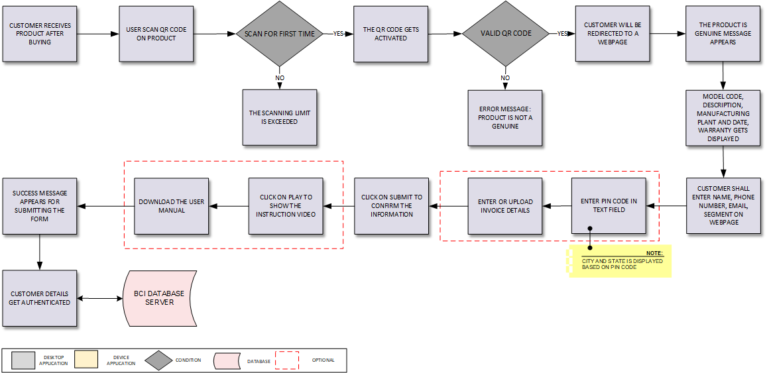

**Activities**

|  |  |
| --- | --- |
| **Module Description** | This module will be used to guide the Customer/ Consumer for scanning the QR Code on Product. Web Link in QR Code will redirect the Customer on Panasonic Product Authentication Website Web Page. Customer is required to fill up the form and download the User Manual.  Link for Product Authorization will be accessible through Public IP.  *\* User can view the Instructional video if given to the Model Code. This Optional feature need to be confirmed by Customer.* |

|  |  |
| --- | --- |
| **Pre-Conditions** | Product received to Customer should be a Valid Product.  Product should have QR Code.  Web Page link should be valid.  Customer should have Smartphone for scanning. |

|  |  |
| --- | --- |
| **Process Steps** | 1. Product will be delivered to the Customer. 2. Customer uses Smartphone to scan the product's QR code. 3. Scan the QR Code.   *\*QR Code will have model Code and serial number and User Manual Download application link to send the information of QR code to Cloud server.*   1. For First time scan, the QR Code gets activated. 2. If the scanned QR Code is valid: 3. The QR code link will take the user to a web page. 4. The product is genuine message appears. 5. The Model Code, Description, Manufacturing Plant and Date of Manufacturing, Warranty and Serial Number are automatically filled in. 6. The Customer must input the mandatory fields i.e. Name, Phone Number, Segment and Email. 7. The Customer will input the Purchase date and Pin Code in the text field (Optional fields).   *\*The system will automatically fill the City and State text fields based on Pin code.*   1. Insert the invoice copy into the Upload Invoice file column.   *\*The customer's uploading Invoice copy is an optional field.*   1. A success message will appear after the Invoice is successfully uploaded. 2. Following completion of the form's fields, the consumer submits it. 3. A Confirmation message will be displayed that the Product is authenticated on the screen.   *\*If linked in the Configuration Master, an Instructional Video corresponding to the model code will be displayed. User can also download the User Manual. The video option feature will be added once confirmed by the customer.*   1. The pop-up will get displayed and will direct the Customer to download PDF file. 2. The user manual will get displayed on screen and customer can download as required. 3. For Invalid QR Code: 4. Error Message will be displayed: Product is not genuine. 5. For Repeated Scans, an error will be displayed on screen. 6. Corresponding details will get saved in database. |

|  |  |
| --- | --- |
| **Post-Conditions** | 1. Customer entered information will get saved in database. 2. Download manual to be in PDF format. |

|  |  |
| --- | --- |
| **Validations** | 1. An alert should be displayed in QR Code not scanned properly. 2. An alert will be displayed, if the URL of the web link changes. 3. An alert should be displayed, if the model code and serial number for that manufacturing plant are invalid. 4. All mandatory fields are highlighted with (*) in red color on the field. 5. An alert message is displayed in case of data is invalid filled. 6. A message of warning will be sent if the wrong pin code is entered. 7. Validation of mobile numbers will be done using country-specific digit numbers. 8. The dot (.) and @ (at) symbol shall be there in the e-mail address. 9. User can upload invoice in file formats like “.pdf”, “.PNG”, “.JPG” and application can accept less than 5Mb file during upload. This limit can be extended. 10. User manual can be viewed and downloaded by the user. 11. System will capture Location if Location permission is allowed by User. 12. System shall maintain the details of source IP address of the customers. 13. An alert should be displayed in case Customer exceeds the limit of accessing the QR Code link and downloading the User Manual (if linked with Model).   *\*If user exceeds the limit, OTP-based access will be provided to Customer on request. Panasonic will provide API for sending OTP based SMS to user and validating the entered OTP by user.* |

|  |  |
| --- | --- |
| **Sample Screen** | **Screen displayed in Laptop/System View:**-    **Screen displayed in Mobile View:-**    **After submitting the Web form, a pop-up should get displayed with the following message:**    **For Specific models only the User Manual Download screen will appear**    **After Submitting data then Download manual Screen appears :-** |

### View Customer Details

**Activities**

|  |  |
| --- | --- |
| **Module Description** | Users of Panasonic will be able to view and export customer information in Excel/Csv format from this module who have downloaded the Product's User Manual. This will give Panasonic Life Solution a complete perspective of the customers. |

|  |  |
| --- | --- |
| **Pre-Conditions** | Check particular Model No details are downloaded by customer. |

|  |  |
| --- | --- |
| **Process Steps** | User will login to the web portal.  A tabular format get displayed on screen with all customer details filled while product authenticated and user manual download form.  User will select the Customer Name from the dropdown list.  Item Code, Description, Manufacturing Plant, Manufacturing Date, Warranty, Customer Name, Location (City, State, and Pin code), Invoice Number, Product Model Code, Serial Number, Phone Number and Email will get displayed.  Click on Invoice Copy link to download the Invoice.  Click on Export to download in Excel/ Csv format.  Click on Filter option to filter the data as per user choice.  *\*The date sorting feature can be used by the user to sort the date.*  *\*User manual download dates can be filtered by filling From and To date.*  User can search particular data by use of search option. |

|  |  |
| --- | --- |
| **Validations** | 1. By default, the customer details will be sorted in date (downloaded date) wise in descending order so that latest downloaded record will be shown first, however user can change the sorting directing by clicking on column header. 2. An alert message is displayed in case of any error / invalid activity. |

|  |  |
| --- | --- |
| **Sample Screen** | **View Customer Details**    **Filter Customer Details**    **Search Customer Details** |

# Deviation Report

The following details will provide an overview of the deviation between the proposed solution and the newly requested solution.

|  |  |  |  |  |  |  |  |  |
| --- | --- | --- | --- | --- | --- | --- | --- | --- |
| **SR No** | **Process** | **Proposed Solution** | **New Development (Y/N)** | **Code Change (Y/N)** | **Part of SD (Y/N)** | **New / Change Requirement** | **Man days** | **Remarks** |
| 1 | Module Master | Additional fields to be maintained in the module master | N | Y | N | Changes New fields like "Warranty" & "Module Category" fields to be maintained in the module master. These fields should be available in the QR code printing module for selection. | 1 | -- |
| 2 | QR Code Printing | TIJ/CIJ printer Integration | Y | N | N | Changes TIJ/CIJ printer integration to be done along with developing printing as new module here | 3 | Customer to share the protocol document and basis that BCI to do the printer integration |
| 3 | Product Authentication | Optional Parameters | N | Y | N | Changes  Some of the portions like "User manual linkage", "Instruction video" & "Customer entry form" these all should be optional. Need to add configuration module as separate to enable or disable these sections in the application Customer also want that the serial number validation attempt should have limit. If exceeded then there should be option to allow again | 3 | Customer information entry form as well non mandatory for Panasonic Life Solution |
| 4 | Serialization | Encrypted | N | Y | N | Serial number in the QR code URL should be encrypted. So that no one can create the URL manually for next serial number. | 1 | -- |

# SRS Scope Change Process

## Before Sign Off

Any changes in SRS need to be informed in writing by Panasonic Life Solutions Pvt Ltd. It will be incorporated / confirmed only after doing detailed feasibility study by BCI.

* If any change is out of scope then this would be done as a CR post feasibility and priority will be decided based on mutual agreement.
* Once the change is developed , any further change in the same would be considered as a CR

## After Sign Off

Any changes in proposed solution after approval of this document by Panasonic Life Solutions Pvt. Ltd. are subjected to confirmation from BCI, taking feasibility constraints into account. These changes will be incorporated (if any) into the solution only after delivering proposed solution & may be charged as extra.

* Any change in the proposed solution due to customer system design or process will be considered as CR
* Any process which is not mentioned in this document will not be considered as “mutual understanding or default presence or standard practice”.

The changes in proposed solution before & after acceptance will be mutually agreed and duly signed and accepted by Panasonic Life Solutions Pvt. Ltd. & BCI.

## SRS Acceptance

|  |  |
| --- | --- |
| **For Panasonic Life Solutions Pvt. Ltd.** | **For Bar Code India (BCI)** |
| **Name:** | **Name:** |
| **Designation:** | **Designation:** |
| **Department:** | **Department:** |

Agreed and Accepted by Panasonic Life Solutions Pvt. Ltd. and Bar Code India